
Using Google Docs is a free alternative to Mac Pages or Microsoft Word. Very similar in all commands, it’s easy to set up a manuscript template to use over and over again.
To get to Google docs, go to http://docs.google.com


Text style and size are setup in the menu top.
Alignment and line spacing are also within the top ribbon. Set alignment to left-aligned, and spacing to double.
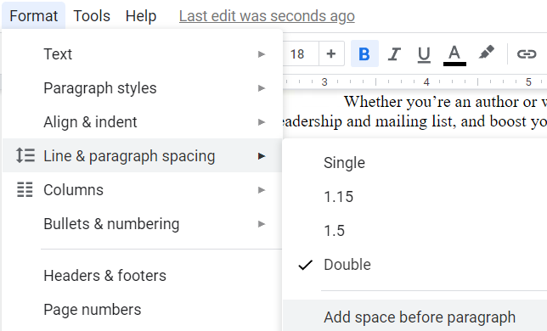
If this is not seen, open the menu up further by clicking on the down arrow on the extreme right of the ribbon.

Line spacing is found under the Format/Line & paragraph spacing.
You can also set alignment and indentation, headers, and page numbers here.

The margins are set up by pulling the ruler on the top of the page to the desired width.

Go to TOOLS for preferences in typing and corrections.

